8-BIT SUBTRACTION WITH BORROW USING DIRECT ADDRESSING

AIM:
To write an assembly language program to subtract tow numbers of 8-bit data stored in memory locations 4200H and 4201H and store the result in 4202H and 4203H with borrow using direct addressing.

APPARATUS REQUIRED:
- 8085 microprocessor kit 1
- Power card 1
- Keyboard 1

ALGORITHM:
- Load the second data from memory to the accumulator and move it to the B register.
- Load the first data from memory to the accumulator.
- Subtract the content of B – register from accumulator
- If Carry flag = 0 then jump to step 5 & 6
- Increment C register to count the borrow
- Take two’s complement of the difference
- Store the Difference in memory.
- Move the borrow to accumulator and store in memory.
- Stop.
Output:
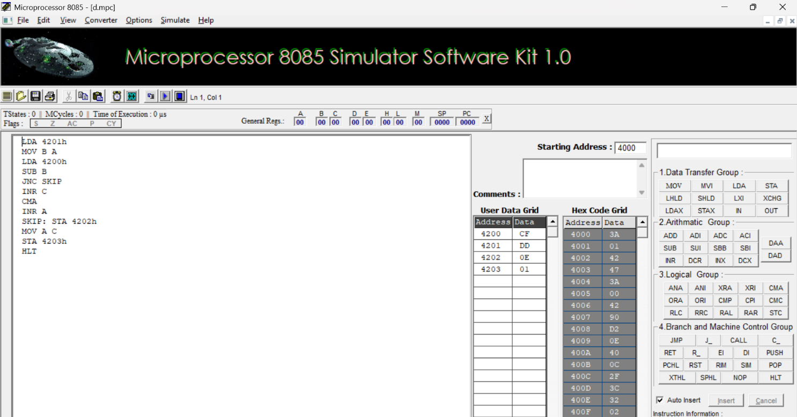

RESULT:
Thus, an assembly language program for subtraction of two 8-bit numbers with borrow was written, executed and Verified the Result successfully using 8085 kit.

